**Sartre, Jean-Paul (21 June 1905 – 15 April 1980)**

Variant forms: Sartre ; Jean-Paul Sartre ; J-P Sartre ; J.-P. Sartre ; Jean Paul Sartre

Authors: Koenig, Raphael and Vial, Caroline [form: Last name; First name]

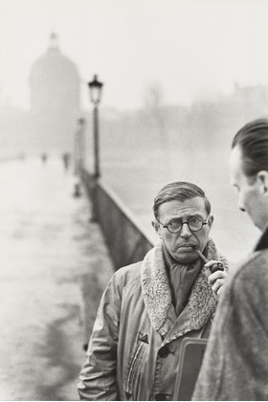

Jean-Paul Sartre photographed by Henri Cartier-Bresson, Paris, 1946.

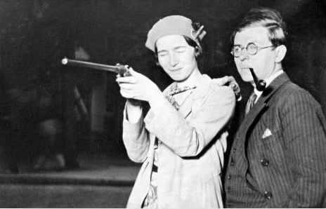

Simone de Beauvoir and Jean-Paul Sartre at a fairground, Paris, 1929.

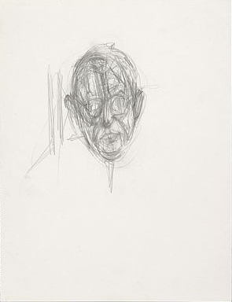 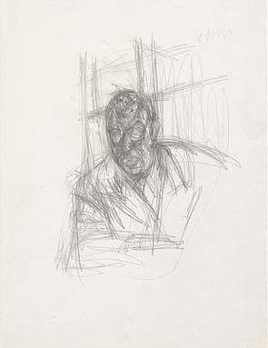

Alberto Giacometti, [Head of Jean-Paul Sartre] and [Jean-Paul Sartre Leaning on his Elbow], Pencil and eraser on paper, 1949

Jean-Paul Sartre was a French philosopher, left-wing political activist, playwright, and novelist. One of the leading French public intellectuals of the twentieth century, he was a key figure in the intellectual field in the decade following the Second World War. Influenced by Edmund Husserl, Martin Heidegger, and Marxism, he was a major theorist of existentialism. For Sartre, human nature is not a given but derives from a personal choice. Based on ontological reflection, Sartre’s existentialism thus leads to the practical realm of ethics and politics, by laying emphasis on the moral responsibility of the individual cut off from the thing-in-itself and condemned to be free. Accordingly, Sartre was both the author of major philosophical treatises and an indefatigable political activist advocating for decolonization, women rights, freedom of speech, and social justice. He was also a prolific novelist, playwright, and literary critic.

Sartre graduated from the École Normale Supérieure in 1929, the year he met his lifelong partner and fellow philosopher Simone de Beauvoir, and published his first novel, *La Nausée* (*The Diary of Antoine Roquentin*, tr. 1949 / *Nausea*, tr. 1965), in 1938. A canonical work of EXISTENTIALISM, *La Nausée* explores the relationship of contingency and necessity in Roquentin’s ability to define himself and his freedom. The collection of stories *Le Mur* (*The Wall, and Other Stories*, tr. 1948), published in the same year, also brought him immediate recognition as another expression of his early themes of alienation, freedom and artistic salvation. He then published *L’Être et le Néant* (*Being and Nothingness*, tr. 1956), his philosophical magnum opus, in 1943. This work provides a detailed account of his existentialist thought: Sartre describes consciousness as always self-conscious, as opposed to matter; hence it escapes determinism, and thus is essentially ‘for itself’ (*pour soi*) as the source of freedom. Freedom of choice is not idealized, according to Sartre, but rather, it is conceived within one’s contingent, historical circumstances. With freedom comes the social responsibility of giving meaning to an otherwise groundless existence.

Sartre rose to prominence in French artistic and literary circles after the Second World War, as existentialism gradually replaced surrealism as the common idiom of the French avant-garde. He was part of a group of artists and intellectuals that included Alberto Giacometti, Jean Genet, Boris Vian, and Simone de Beauvoir. Sartre and Beauvoir co-founded the pivotal literary magazine *Les* *Temps* *Modernes* (*Modern* *Times*) in October 1945, which was meant to replace the *Nouvelle* *Revue* *Française* (*New* *French* *Review*), the leading literary magazine of the interwar period perceived as morally and politically discredited due to its active collaboration with the Nazis and the Vichy regime.

Sartre’s existentialist ethics can be glimpsed in his novels and plays, in particular in the four-volume novel *Les Chemins de la liberté* (*The Roads to Freedom*), of which Sartre only wrote three volumes: *L’Âge de raison* (1945; *The Age of Reason*, tr. 1947), *Le Sursis* (1945; *The Reprieve*, tr. 1947) and, *La Mort dans l’âme* (1949; *Iron in the Soul*, tr. 1950 / *Troubled Sleep*, tr. 1953). The trilogy portrays the wartime struggles of Parisian intellectuals with the notion of freedom; it presents a more grounded view of EXISTENTIALISM, tracing the progression of the effects of the Second World War on Sartre’s thought toward ‘engagement’ in both life and literature. The shift in his philosophical position toward conceiving of freedom as a social responsibility culminated in Sartre’s immensely popular public lecture “L’Existentialisme est un humanisme” (1946; *Existentialism and Humanism*, 1948), which he presented in Paris on October 28, 1945.

During the same decade, Sartre wrote several successful plays, including *Les Mouches* (1943; *The Flies*, tr. 1946), which allegorizes the German occupation through the myth of Orestes. *Huis Clos* (1945; *In Camera*, tr. 1946 / *No Exit*, tr. 1947) explores issues of self-consciousness and tormented relationships, where three deceased characters are doomed to remain together in a room for eternity. *Les Mains Sales* (1948; *Crime Passionnel*, tr. 1949 / *Dirty Hands*, tr. 1949), set in a fictional Communist country in Eastern Europe during the Second World War, depicts a killer’s philosophical or political motivations behind a killing. Other plays of the same period include *Le Diable et le bon Dieu* (1951; *Lucifer and the Lord*, tr. 1952) and *Les Séquestrés d’Altona* (1959; *Loser Wins*, tr. 1960 / *The Condemned of Altona*, tr. 1961).

Sartre devoted a considerable part of his career to literary criticism. Many of the articles of literary criticism that first appeared in *Les* *Temps* *Modernes* were later published as a series entitled *Situations*, between 1947 and 1976. In his famous series of essays, *Qu’est-ce que la littérature?* (1948; *What is Literature?*, tr. 1949), Sartre expounds on his ethical shift toward the social responsibility of the intellectual, and a committed literature (*littérature* *engagée*), which prose can achieve, whereas poetry cannot. This marks his rejection of the literary practice of “L’art pour l’art” (*art for art’s sake*). Other publications of literary criticism in this period include his book *Baudelaire* (1947; tr. 1949) and *Saint Genet, comédien et martyr* (1952; *Saint Genet, Actor and Martyr*, tr. 1963).

Sartre’s influence started to decline from the early 1960s onwards with the advent of structuralism. However, Sartre remained a looming figure of French intellectual and political life until his death in 1980. His *Critique de la raison dialectique* (1960; *Critique of Dialectical Reason*, tr. 1976) reflects his engagement with social and political issues in Marxism, questions of choice, historical contingency and its material restrictions on freedom. Sartre’s last major works include his autobiography, *Les Mots* (1963; *The Words*, tr. 1964) and *L’Idiot de famille* (1971-72; *The Family Idiot*, tr. 1981-1993), a biographical study of Gustave Flaubert.

**Timeline**

1905: Born in Paris.

1920-1929: reads Philosophy at the École normale supérieure in Paris, with fellow students Raymond Aron, Georges Canguilhem, and Paul Nizan.

1929: start of a lifelong relationship with Simone de Beauvoir.

1933: studies at the French Institute in Berlin, where he discovers Martin Heidegger’s *Being and Time*.

1938: Publication of Sartre’s first novel, *Nausea*.

1943: Publication of Sartre’s philosophical magnum opus *Being and Nothingness*.

1943-1944: His theater plays *The Flies* and *No Exit* are staged in Paris.

October 1945: Sartre becomes the founding director of *Les Temps modernes* (Modern Times). In its first issue, Sartre defines the review as a tribune for littérature engagée, i.e. literature serving a political or ethical cause.

October 29th, 1945: Sartre’s controversial conference *Existentialism and Humanism* (later published in book form) launches existentialism on the French artistic and intellectual scene.

1952-1956: He is closely associated with the French Communist Party.

November 1956: He distances himself from the Communist Party and denounces the repression of the Hungarian revolution by the Soviet army.

1960: Publication of the *Critique of Dialectical Reason*, a landmark of Western Marxism.

September 6th, 1960: Sartre is one of the signatories of the *Manifesto of the 121*, an open letter to the French government denouncing the use of torture by the French army in Algeria and supporting the cause of Algerian independence.

1961: He writes the preface to Frantz Fanon’s *The Wretched of the Earth*, a pivotal work of anti-colonialist thought.

1964: He publishes his autobiography, *Words*.

October 1964: He is awarded the Nobel Prize for Literature and refuses the award.

1966: He takes part in the Russell Tribunal, an international gathering of activists, intellectuals, and victims denouncing American war crimes in Vietnam.

1971-1972: He publishes his major study on Flaubert, *The Family Idiot*.

1973: He is co-founder of the left-wing daily newspaper *Liberation*.

April 15th, 1980: He dies in Paris.

**References and Further Reading**

Astruc, Alexandre, Contat, Michel, and Séligmann, Guy (1983) *Sartre by Himself* [videorecording]. Chicago: Citadel Video Ltd. This documentary offers a wealth of archival material about Sartre’s life and work, including substantial interviews with Sartre and Beauvoir.

Catalano, Joseph S. (2010) *Reading Sartre*. New York: Cambridge University Press. This essay offers a comprehensive analysis of Sartre’s major works of philosophy and literary criticism, including *Being of Nothingness*, *Saint Genet: Actor and Martyr*, *The Critique of Dialectical Reason*, and *The Family Idiot*.

Cohen-Solal, Annie (1987) *Sartre: a Life.* New York: Pantheon Books. Annie Cohen-Solal’s book remains the most authoritative biography of Sartre to date.

Webber, Jonathan (2010) (ed.) *Reading Sartre: On Phenomenology and Existentialism.* Routledge: Abingdon and New York. A collective volume covering major aspects of Sartre’s thought, such as its relationship to ontology, phenomenology, and ethics.

Wittmann, Heiner (2009) *Aesthetics in Sartre and Camus: The Challenge of Freedom.* Peter Lang: Frankfurt, Berlin, Bern. A groundbreaking study of Sartre and Camus’ relationship to aesthetics and visual arts, this book includes a detailed analysis of Sartre’s writings on Wols, Calder, Tintoretto, and Giacometti.

**List of major works**

1936 – *L’Imagination* (*Imagination: A Psychological Critique*, tr. 1962)

1938 – *La Nausée* (*Nausea*, tr. 1949)

1939 – *Le Mur* (*The Wall*, tr. 1948)

1939 – *Esquisse d’une théorie des émotions* (*The Emotions: Outline of a Theory*, tr. 1948)

1940 – *L’Imaginaire (The Imaginary*, tr. 2004)

1943 – *L’Être et le néant* (*Being and Nothingness*, tr. 1956)

1943 – *Les Mouches* (*The Flies*, tr. 1946)

1945 – *Huis Clos* (*No Exit*, tr. 1947)

1945 – *L’Âge de raison* (*The Age of Reason*, tr. 1947)

1945 – *Le Sursis* (*The Reprieve*, tr. 1947)

1946 – *L’Existentialisme est un humanisme* (*Existentialism and Humanism*, tr. 1948)

1947 – *Baudelaire* (*Baudelaire*, tr. 1949)

1948 *– Qu’est-ce que la littérature?* (*What is Literature?*, tr. 1949)

1949 – *La Mort dans l’âme* (*Iron in the Soul*, tr. 1950 / *Troubled Sleep*, tr. 1951)

1951 – *Le Diable et le bon dieu* (*Lucifer and the Lord*, tr. 1952)

1952 – *Saint Genet, comédien et martyr* (*Saint Genet, Actor and Martyr*, tr. 1963)

1960 – *Critique of Dialectical Reason* (*Critique of Dialectical Reason*, tr. 1976)

1960 – *Les Séquestrés d’Altona* (*Loser* Wins, tr. 1960 / The *Condemned of Altona*, tr. 1961)

1964 – *Les Mots* (*The Words*, tr. 1964)

1971-1972 – *L’Idiot de Famille: Gustave Flaubert de 1821-1857* (*The Family Idiot: Gustave Flaubert, 1821-1857*, tr. 1981-1993)

URL of Illustrations

Sartre by Cartier-Bresson

<http://www.moma.org/collection/object.php?object_id=49467>

Copyright Holder: Henri Cartier-Bresson / Magnum

Beauvoir and Sartre at a fairground

<http://thephotographersgallery.org.uk/existential-photography>

Copyright holder:

Jazz Editions / Gamma / Gamma-Rapho

Alberto Giacometti,

[Head of Jean-Paul Sartre]

http://www.fondation-giacometti.fr/en/art/16/discover-giacometti/18/alberto-giacometti-database/22/graphic-arts/#?ref=database&open=drawings&work=758

[Jean-Paul Sartre Leaning on his Elbow],

<http://www.fondation-giacometti.fr/en/art/16/discover-giacometti/18/alberto-giacometti-database/110/selected-works/#?work=769>

Copyright holder: Fondation Giacometti (same website)

Two more illustrations:

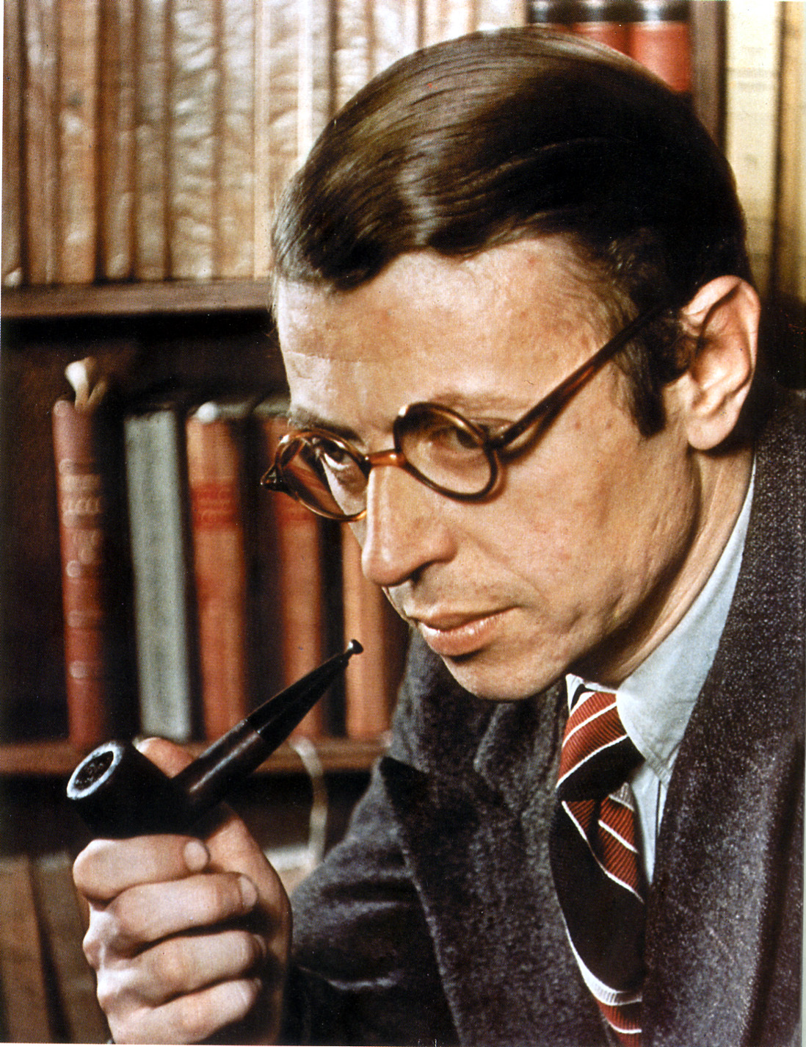

Photographic Source: http://3.bp.blogspot.com/-nWUTuaZF8FM/T5Z6fX6YkKI/AAAAAAAACgU/RT7z3js92CU/s1600/jean-paul-sartre-.jpg

Other photograph (taken with Simone de Beauvoir):

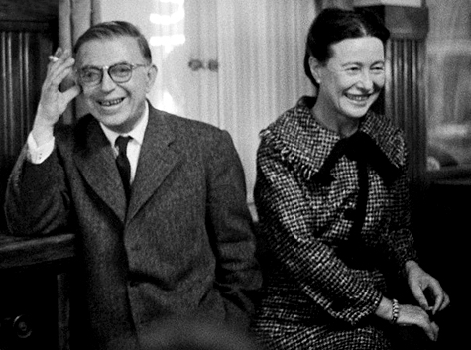

source: http://4.bp.blogspot.com/-3XMDzVplih0/T4GVQmZtEjI/AAAAAAAALF0/bOZetswHn3c/s1600/tumblr_lf6ydnvByL1qa9op5o1_500.jpg